# **City bike-share usage forecasting tool using historical rental data and predictive analytics**

**Abstract:**

This project focuses on developing a bike-share usage forecasting tool using historical rental data and predictive analytics. By collecting and preprocessing data, and conducting exploratory analysis, usage patterns are identified. Implementing various predictive models, including time series and machine learning algorithms, demonstrates improved accuracy in forecasting bike-share usage. The tool supports city planners and operators in optimizing resource allocation and enhancing user satisfaction. It also suggests future research directions to further refine forecasting capabilities and operational efficiency in bike-share systems. The results demonstrate the effectiveness of the chosen methodologies in accurately predicting bike-share usage, with significant improvements over baseline models. The developed forecasting tool offers valuable insights for city planners and bike-share operators, enabling data-driven decision-making for better management of bike-share systems. The study also highlights potential real-time applications and suggests areas for future research to further enhance forecasting accuracy and operational efficiency.

**Keywords:** Exploratory analysis, Machine learning algorithms, Methodologies, Predictive Analytics.

**Content**

* Introduction
* Literature Survey
* System Analysis
* Methodologies
* System Design
* Testing
* Result
* Conclusion
* Reference

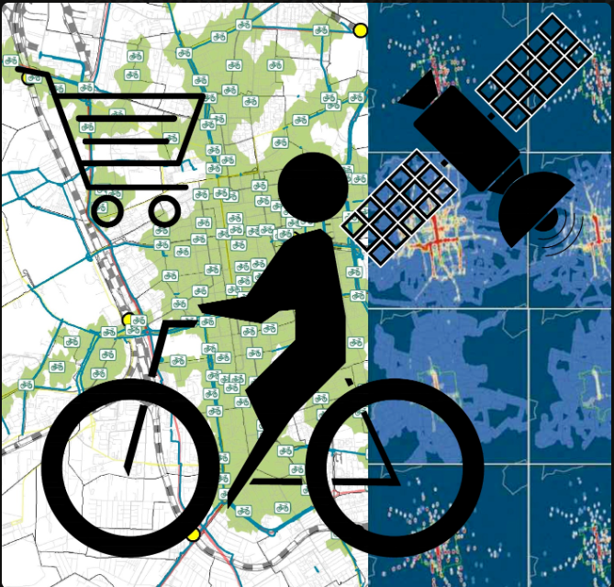

Fig: Bike-share usage forecasting

**Chapter 1: Introduction**

* 1. **Aim of the project:**

The primary aim of this project is to develop a reliable forecasting tool for bike-share usage utilizing historical rental data and predictive analytics. By accurately predicting usage patterns, the tool aims to:

1. Optimize resource allocation and fleet management within bike-share systems.
2. Enhance user experience by ensuring sufficient bike availability at high-demand locations and times.
3. Enable informed decision-making for city planners and bike-share operators to improve system efficiency.
4. Contribute to sustainable urban transportation initiatives by promoting bike-sharing as a viable alternative.

Through these objectives, the project aims to demonstrate the effectiveness of data-driven approaches in optimizing bike-share system operations and fostering sustainable urban mobility solutions.

* 1. **Objective of the project:**

The project aims to achieve the following objectives:

1. **Develop a Forecasting Tool:** Create a robust tool using historical bike-share rental data and predictive analytics techniques.
2. **Predict Usage Patterns:** Accurately forecast bike-share usage patterns to understand peak times, popular routes, and seasonal variations.
3. **Optimize Resource Allocation:** Enable city planners and operators to optimize bike distribution and fleet management based on predicted demand.
4. **Enhance User Experience:** Improve user satisfaction by ensuring adequate bike availability and reducing wait times.
5. **Support Decision-Making:** Provide actionable insights for informed decision-making in bike-share system planning and operations.
6. **Promote Sustainability:** Contribute to sustainable urban transportation goals by promoting the use of bike-share systems as a green transportation option.

By achieving these objectives, the project seeks to demonstrate the value of predictive analytics in improving operational efficiency and user experience within urban bike-share systems.

* 1. **Scope of the project:**

The scope of this project includes:

1. **Data Collection and Preprocessing:** Gathering historical bike-share rental data from relevant sources and preparing it for analysis.
2. **Exploratory Data Analysis (EDA):** Conducting EDA to identify usage patterns, trends, and correlations in the data.
3. **Model Development:** Implementing and evaluating various predictive models such as time series analysis, regression models, and machine learning algorithms.
4. **Forecasting Tool Implementation:** Developing a software tool or framework that integrates the predictive models to forecast bike-share usage.
5. **Performance Evaluation:** Assessing the accuracy and effectiveness of the forecasting tool through rigorous testing and validation against historical data.
6. **Recommendations and Applications:** Providing actionable recommendations based on the forecasting results to optimize bike allocation, improve user experience, and support decision-making for city planners and bike-share operators.
7. **Documentation and Reporting:** Documenting the entire process, methodologies, results, and conclusions in a comprehensive report or documentation.
8. **Limitations:** Recognizing and addressing potential limitations in data availability, model accuracy, and generalizability.

The project focuses on developing a practical forecasting tool that can be implemented and utilized by stakeholders involved in managing urban bike-share systems, aiming to enhance system efficiency, user satisfaction, and overall sustainability.

**Chapter 2: Literature Survey**

**2.1 Background:**

The background of this project lies in the growing importance of bike-share systems as a sustainable and flexible mode of urban transportation. These systems allow users to rent bicycles for short-term use, promoting mobility, reducing traffic congestion, and minimizing environmental impact. However, efficient management of bike-share fleets requires accurate prediction of usage patterns to optimize bike availability and distribution.

Traditional approaches to bike-share management often rely on static scheduling and manual adjustments, which may not fully utilize system capacity or meet dynamic user demands. In contrast, predictive analytics offers a data-driven solution by leveraging historical rental data and advanced statistical techniques to forecast future usage trends.

By developing a forecasting tool for bike-share systems, this project aims to harness the power of predictive analytics to improve operational efficiency, enhance user experience, and support sustainable urban transportation initiatives. The project builds on existing research in transportation analytics and aims to contribute practical insights and tools for optimizing bike-share system management in urban environments.

**2.2 Related work:**

Previous research and related work in bike-share usage forecasting and management have explored various methodologies and approaches:

1. **Predictive Analytics in Transportation:** Studies have applied predictive modeling techniques, including time series analysis, regression models, and machine learning algorithms, to forecast transportation demand and optimize resource allocation.
2. **Data-Driven Approaches:** Researchers have utilized large-scale datasets from bike-share systems to analyze usage patterns, understand user behavior, and develop predictive models for system optimization.
3. **Spatial and Temporal Analysis:** Spatial analysis techniques have been employed to identify hotspots of bike-share activity and temporal patterns to predict peak usage times and seasonal variations.
4. **Decision Support Systems:** Development of decision support tools and frameworks that integrate predictive models to assist city planners and bike-share operators in making informed decisions about system expansion, bike redistribution, and infrastructure planning.
5. **Case Studies and Applications:** Case studies from various cities worldwide have demonstrated the practical application of predictive analytics in improving bike-share system efficiency, enhancing user satisfaction, and promoting sustainable urban mobility.
6. **Challenges and Limitations:** Literature also discusses challenges such as data quality, model accuracy, scalability, and the need for real-time forecasting capabilities to address dynamic urban environments effectively.

By building on these insights and methodologies, this project aims to contribute to the advancement of predictive analytics in bike-share system management, providing a practical tool for optimizing resource allocation and enhancing user experience in urban transportation networks.

**2.3.1 Existing Methodology:**

The existing methodologies in bike-share usage forecasting typically involve the following approaches and techniques:

1. **Time Series Analysis:** Utilizing historical rental data to identify patterns and trends over time, such as daily, weekly, and seasonal variations in bike usage. Techniques like ARIMA (AutoRegressive Integrated Moving Average) and its variants are commonly used for time series forecasting.
2. **Regression Models:** Building regression models to predict bike-share demand based on various explanatory variables such as weather conditions (temperature, precipitation), day of the week, holidays, and special events. Linear regression, polynomial regression, and generalized additive models (GAMs) are often employed for this purpose.
3. **Machine Learning Algorithms:** Applying supervised learning algorithms such as decision trees, random forests, support vector machines (SVM), and neural networks to capture complex relationships in the data and improve forecasting accuracy. These models can handle nonlinearities and interactions between predictor variables.
4. **Spatial Analysis:** Analyzing spatial patterns of bike usage using geographic information systems (GIS) to identify popular routes, stations, and hotspots. Spatial regression models and clustering techniques help in understanding spatial dependencies and optimizing bike distribution.
5. **Ensemble Methods:** Combining multiple forecasting models (ensemble methods) to improve prediction accuracy and robustness. Techniques like model averaging, stacking, and boosting are used to leverage the strengths of different models.
6. **Hybrid Approaches:** Integrating multiple data sources and methodologies (e.g., combining time series forecasting with machine learning techniques) to enhance the predictive power of models and accommodate diverse urban contexts and operational conditions.
7. **Evaluation Metrics:** Using metrics such as Root Mean Squared Error (RMSE), Mean Absolute Error (MAE), Mean Absolute Percentage Error (MAPE), and R-squared (R²) to evaluate the performance of forecasting models and compare different approaches.

These methodologies are continuously evolving with advancements in data analytics, machine learning, and urban transportation research, aiming to provide accurate and actionable insights for bike-share system management and planning.

**2.3.2 Drawbacks of Existing system:**

Despite advancements in bike-share system management, several drawbacks and challenges persist:

1. **Data Quality Issues:** Incomplete or inaccurate data collection can hinder the effectiveness of predictive models, leading to unreliable forecasts and suboptimal resource allocation.
2. **Limited Predictive Power:** Traditional forecasting methods may struggle to capture complex and dynamic patterns in bike-share usage, particularly during events or unusual weather conditions.
3. **Scalability Concerns:** As bike-share systems expand to larger networks and serve increasing numbers of users, scalability becomes a critical issue. Existing models may struggle to handle the volume and variety of data required for accurate predictions.
4. **Sensitivity to External Factors:** Predictive models reliant on weather, holidays, or special events may be sensitive to unforeseen changes or inaccuracies in external data sources, impacting forecasting accuracy.
5. **Temporal and Spatial Variability:** The temporal and spatial variability of bike-share usage patterns can challenge the generalizability of models across different cities or neighborhoods, requiring tailored approaches for specific contexts.
6. **Real-Time Adaptability:** Many existing systems lack real-time forecasting capabilities, limiting their ability to respond dynamically to sudden changes in demand or operational conditions.
7. **Integration Challenges:** Integrating predictive analytics tools into existing bike-share management systems and workflows may require significant technical and organizational adjustments, posing implementation barriers.
8. **User Behavior Dynamics:** Changes in user preferences, behaviors, and adoption rates of bike-share systems over time may not be adequately captured by static forecasting models, necessitating adaptive and responsive forecasting approaches.

Addressing these drawbacks requires ongoing research and development efforts to improve data quality, enhance predictive modeling techniques, and integrate real-time analytics capabilities into bike-share system management practices. These efforts aim to optimize system efficiency, enhance user experience, and promote sustainable urban mobility solutions effectively.

**2.4.1 Proposed Methodology:**

The proposed methodology for bike-share usage forecasting integrates advanced analytics techniques to address existing drawbacks and enhance system efficiency:

1. **Data Collection and Preprocessing:**
   * Gather comprehensive historical rental data, including timestamps, locations, and user demographics.
   * Cleanse and preprocess data to handle missing values, outliers, and ensure consistency for reliable analysis.
2. **Exploratory Data Analysis (EDA):**
   * Conduct EDA to uncover temporal and spatial patterns, trends, and correlations in bike-share usage.
   * Use visualization techniques to identify peak times, popular routes, and seasonal variations.
3. **Feature Engineering:**
   * Extract relevant features such as weather conditions, day of the week, holidays, and special events that influence bike-share usage.
   * Transform and engineer features to enhance predictive model performance.
4. **Predictive Modeling:**
   * Implement a hybrid approach combining time series analysis and machine learning algorithms.
   * Develop time series forecasting models (e.g., ARIMA, SARIMA) to capture temporal dependencies and seasonal patterns.
   * Employ supervised learning techniques (e.g., regression models, ensemble methods, neural networks) to incorporate external factors and nonlinear relationships.
5. **Model Training and Validation:**
   * Train models on historical data and validate their performance using cross-validation techniques.
   * Evaluate models using appropriate metrics (e.g., RMSE, MAE) to assess accuracy and robustness.
6. **Real-Time Forecasting and Adaptation:**
   * Implement real-time forecasting capabilities to adjust predictions dynamically based on current data inputs.
   * Integrate feedback mechanisms to continuously update and refine forecasting models.
7. **Integration and Deployment:**
   * Integrate the forecasting tool into existing bike-share management systems, ensuring compatibility and scalability.
   * Collaborate with stakeholders to facilitate seamless deployment and adoption of predictive analytics tools.
8. **Evaluation and Optimization:**
   * Monitor model performance in real-world settings and iteratively optimize forecasting algorithms.
   * Conduct sensitivity analyses to assess model reliability under varying conditions and external influences.
9. **Documentation and Knowledge Transfer:**
   * Document methodologies, findings, and implementation details for transparency and knowledge sharing.
   * Provide training and support to stakeholders for effective utilization of the forecasting tool.

By adopting this methodology, the project aims to enhance bike-share system management, optimize resource allocation, and improve user satisfaction through accurate and proactive forecasting of bike-share usage patterns.

**2.4.2 Advantages of Proposed system:**

The proposed system offers several advantages over traditional approaches, leveraging advanced analytics to enhance bike-share system management:

1. **Improved Accuracy:** Integrates sophisticated predictive models, including time series analysis and machine learning algorithms, to accurately forecast bike-share usage patterns. This improves the reliability of predictions compared to simpler forecasting methods.
2. **Enhanced Resource Optimization:** Enables efficient allocation of bikes and resources based on predicted demand, reducing instances of underutilization or shortages at popular locations and times.
3. **Real-Time Adaptability:** Incorporates real-time forecasting capabilities to adjust predictions dynamically in response to changing conditions, such as weather fluctuations or unexpected events.
4. **Comprehensive Insights:** Provides actionable insights through detailed exploratory analysis and feature engineering, uncovering hidden patterns and trends in bike-share usage data.
5. **Scalability:** Designed to scale with growing bike-share networks and increasing volumes of data, accommodating diverse urban environments and operational demands.
6. **User-Centric Design:** Improves user experience by ensuring availability of bikes when and where needed, enhancing convenience and satisfaction among bike-share system users.
7. **Decision Support:** Supports informed decision-making for city planners and bike-share operators, facilitating strategic planning, system expansion, and infrastructure investments.
8. **Promotion of Sustainability:** Promotes sustainable urban mobility by optimizing bike-share system efficiency, reducing reliance on motor vehicles, and lowering carbon emissions.
9. **Integration and Collaboration:** Facilitates seamless integration into existing bike-share management frameworks, fostering collaboration among stakeholders and enhancing overall system effectiveness.

By leveraging these advantages, the proposed system aims to advance bike-share system management practices, optimize operational efficiencies, and contribute to sustainable urban transportation solutions effectively.

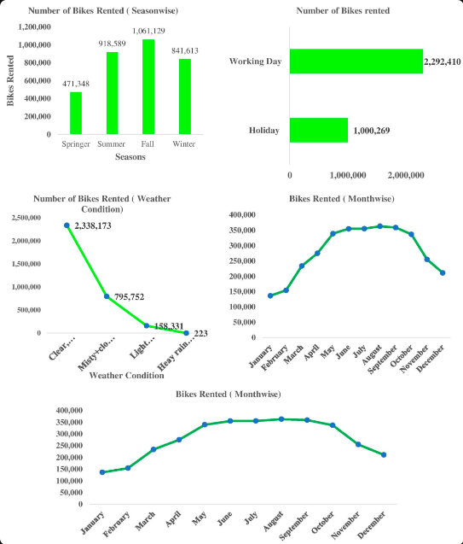

**Chapter 3: System Analysis**

**3.1 Software Requirements:**

To develop and implement the proposed bike-share usage forecasting tool, the following software requirements are recommended:

1. **Programming Languages:**
   * **Python:** Preferred for its rich ecosystem of data analysis libraries (e.g., Pandas, NumPy, Scikit-learn) and support for machine learning.
   * **R:** Optionally used for statistical modeling and visualization, particularly for advanced time series analysis.
2. **Integrated Development Environment (IDE):**
   * **Jupyter Notebook or JupyterLab:** Ideal for interactive data analysis, model prototyping, and documentation with Markdown support.
   * **PyCharm, VS Code, or Spyder:** Suitable for Python development with debugging capabilities and project management features.
3. **Data Analysis and Machine Learning Libraries:**
   * **Pandas:** For data manipulation and preprocessing tasks.
   * **NumPy:** Essential for numerical operations and array manipulation.
   * **Scikit-learn:** Provides a range of machine learning algorithms for model development and evaluation.
   * **Statsmodels:** Useful for advanced statistical modeling, including time series analysis.
4. **Visualization Libraries:**
   * **Matplotlib:** Standard library for creating static, animated, and interactive visualizations.
   * **Seaborn:** Built on top of Matplotlib, offers enhanced statistical graphics for data exploration.
   * **Plotly or Bokeh:** Enables interactive and dynamic visualizations suitable for web-based applications.
5. **Database Management:**
   * **SQLite:** Lightweight, file-based database for local data storage and management.
   * **PostgreSQL or MySQL:** Relational databases for larger datasets and multi-user environments.
6. **Web Development (Optional for Real-Time Applications):**
   * **Flask or Django:** Web frameworks for building web-based dashboards or APIs to deliver real-time forecasts.
   * **HTML/CSS/JavaScript:** Front-end technologies for user interface design and interactivity.
7. **Version Control and Collaboration:**
   * **Git:** Version control system for tracking changes, collaborating with team members, and managing project repositories.
   * **GitHub, GitLab, or Bitbucket:** Platforms for hosting Git repositories and facilitating collaborative development.
8. **Documentation and Reporting:**
   * **Jupyter Notebooks:** Integrated with Markdown cells for documenting code, analysis steps, and results.
   * **LaTeX:** Optionally used for creating formal reports and publications with advanced formatting capabilities.
9. **Deployment and Cloud Services (Optional):**
   * **Docker:** Containerization for packaging the application and dependencies into portable units.
   * **AWS, Azure, or Google Cloud Platform:** Cloud services for deploying and scaling web applications, storing large datasets, and utilizing computing resources.
10. **Project Management and Communication:**
    * **Slack, Microsoft Teams, or Discord:** Communication platforms for team collaboration and project updates.
    * **Trello, Asana, or Jira:** Project management tools for task tracking, scheduling, and milestone management.

By fulfilling these software requirements, the development and implementation of the bike-share usage forecasting tool can proceed effectively, leveraging modern data analytics techniques and ensuring scalability and usability in real-world applications.

**3.2 Hardware Requirements:**

The hardware requirements for developing and deploying the bike-share usage forecasting tool depend on the scale of data, complexity of models, and expected usage scenarios. Here are general recommendations:

1. **Development Workstation:**
   * **Processor:** Multi-core processor (e.g., Intel Core i7 or AMD Ryzen 7) for efficient data processing and model training.
   * **RAM:** Minimum 16 GB RAM to handle large datasets and complex computations. More RAM (32 GB or higher) may be beneficial for handling extensive data preprocessing and machine learning tasks simultaneously.
2. **Storage:**
   * **SSD (Solid State Drive):** Fast storage for quick read/write operations, especially beneficial for handling large datasets and frequent data access during model training and evaluation.
3. **Graphics Processing Unit (GPU) (Optional but Recommended for Machine Learning):**
   * **NVIDIA GPU:** CUDA-enabled GPU (e.g., NVIDIA GeForce RTX series or Tesla GPUs) accelerates training of deep learning models and complex machine learning algorithms. This significantly speeds up computations compared to CPU-only processing.
4. **Cloud Computing (Optional for Scalability):**
   * **Cloud Service Provider:** Utilizing cloud platforms (e.g., AWS, Azure, Google Cloud) provides scalable computing resources, storage, and GPU instances for handling large-scale data analytics and model training.
5. **Server Requirements (Optional for Deployment):**
   * **Processor:** High-performance server-grade processors (e.g., Intel Xeon or AMD EPYC) for handling concurrent requests and real-time data processing.
   * **RAM:** Sufficient RAM (minimum 32 GB or higher) to support multiple users and real-time forecasting capabilities.
   * **Storage:** SSD storage or network-attached storage (NAS) for data persistence and efficient retrieval.
6. **Networking:**
   * **Internet Connectivity:** Stable high-speed internet connection for accessing cloud services, deploying web-based applications, and collaborating with team members.
7. **Backup and Redundancy:**
   * **Data Backup:** Regular backup procedures to prevent data loss and ensure continuity in case of hardware failures or system crashes.
   * **Redundancy:** Implementing redundant systems or failover mechanisms for critical components (e.g., servers, databases) to maintain system availability and reliability.
8. **Environmental Considerations:**
   * **Cooling System:** Adequate cooling solutions (e.g., air conditioning, server room ventilation) to maintain optimal operating temperatures for hardware components, especially in high-performance computing environments.

By aligning hardware resources with the computational demands of data preprocessing, model training, and deployment scenarios, the bike-share usage forecasting tool can operate efficiently, scale effectively, and deliver reliable performance in both development and production environments.

**Chapter 4: Methodologies**

**4.1 Project Life cycle:**

The project life cycle for developing a bike-share usage forecasting tool typically follows these stages:

### 1. Initiation Phase:

* **Project Definition:** Define project objectives, scope, and stakeholders' requirements for the bike-share usage forecasting tool.
* **Feasibility Study:** Assess technical, financial, and operational feasibility of the project, including resource availability and potential constraints.

### 2. **Planning Phase:**

* **Project Plan:** Develop a detailed project plan outlining tasks, timelines, milestones, and deliverables.
* **Resource Allocation:** Allocate human resources, hardware, software, and budget required for development and implementation.
* **Risk Management:** Identify potential risks, uncertainties, and mitigation strategies to ensure project success.

### 3. **Execution Phase:**

* **Data Collection:** Gather historical bike-share rental data and relevant external datasets (e.g., weather, events).
* **Data Preprocessing:** Cleanse, integrate, and transform data to ensure quality and compatibility for analysis.
* **Exploratory Data Analysis (EDA):** Conduct EDA to understand data patterns, correlations, and insights relevant to bike-share usage.
* **Model Development:** Implement predictive models (e.g., time series analysis, machine learning algorithms) for forecasting bike-share usage patterns.
* **Validation and Testing:** Validate models using historical data, evaluate performance metrics (e.g., RMSE, MAE), and refine models as necessary.

### 4. **Deployment Phase:**

* **Integration:** Integrate the forecasting tool with existing bike-share management systems or develop standalone applications.
* **User Training:** Provide training sessions for stakeholders on using the forecasting tool effectively.
* **Pilot Testing:** Conduct pilot tests to validate tool functionality and gather feedback from users for further refinement.

### 5. **Operation and Maintenance Phase:**

* **Monitoring and Optimization:** Monitor tool performance, analyze forecasting accuracy, and optimize models based on real-world data and user feedback.
* **Support and Updates:** Provide technical support, address user queries, and release periodic updates to enhance tool functionality and address issues.

### 6. **Closure Phase:**

* **Project Review:** Evaluate project outcomes against initial objectives and success criteria.
* **Documentation:** Prepare comprehensive documentation covering methodologies, findings, technical specifications, and user manuals.
* **Knowledge Transfer:** Transfer knowledge to stakeholders, including maintenance procedures, operational guidelines, and future development possibilities.

### 7. **Post-Implementation Review:**

* **Evaluation:** Conduct post-implementation review to assess long-term impact, user satisfaction, and adherence to sustainability goals.
* **Lessons Learned:** Document lessons learned, best practices, and areas for improvement to inform future projects and initiatives.

By following a structured project life cycle, organizations can effectively manage the development, implementation, and maintenance of a bike-share usage forecasting tool, ensuring alignment with stakeholder expectations and delivering sustainable benefits to urban mobility and transportation management.

**Libraries:**

For a City bike-share usage forecasting tool using historical rental data and predictive analytics, several libraries in Python would be essential:

1. **Pandas**: For data manipulation and preprocessing.
2. **NumPy**: For numerical operations and array manipulation.
3. **Scikit-learn**: For machine learning algorithms such as regression, ensemble methods, and metrics for model evaluation.
4. **Statsmodels**: For statistical models, particularly useful for time series analysis.
5. **Matplotlib**: For creating static visualizations.
6. **Seaborn**: For statistical data visualization.
7. **TensorFlow or PyTorch** (optional): For implementing deep learning models if needed for more complex forecasting tasks.
8. **Flask or Django** (if developing a web application): For building web interfaces to display forecasts or provide interactive features.

These libraries provide a robust foundation for data preprocessing, modelling, visualization, and deployment aspects of the bike-share usage forecasting tool. Depending on specific requirements and the complexity of the models, additional libraries or frameworks may also be considered.

**4.2 Implementation:**

### **1. Data Collection and Preprocessing:**

* **Collect Historical Data:** Gather comprehensive bike-share rental data, including timestamps, locations, user demographics, and relevant external factors (e.g., weather data).
* **Data Cleaning:** Cleanse the data to handle missing values, outliers, and inconsistencies that could affect model accuracy.
* **Feature Engineering:** Extract and transform features (e.g., time of day, day of week, weather conditions) to enhance predictive modelling capabilities.

### 2**. Exploratory Data Analysis (EDA):**

* **Explore Data Patterns:** Conduct exploratory analysis to uncover insights, trends, and correlations in bike-share usage patterns.
* **Visualize Data:** Use graphs, charts, and statistical summaries to visualize temporal and spatial distributions, peak usage times, and seasonal variations.

### **3. Model Selection and Development**:

* **Choose Predictive Models:** Select appropriate models based on data characteristics and forecasting requirements (e.g., time series models like ARIMA, regression models, machine learning algorithms such as random forests or neural networks).
* **Model Training:** Train the selected models using historical data, tuning parameters, and validating against known outcomes to optimize performance.
* **Ensemble Methods:** Consider using ensemble techniques to combine multiple models for improved accuracy and robustness.

### **4. Integration and Deployment:**

* **Integrate with Existing Systems:** Integrate the forecasting tool with bike-share management systems, APIs, or web interfaces for seamless data flow and user interaction.
* **Develop User Interfaces:** Design user-friendly interfaces for stakeholders (e.g., city planners, bike-share operators) to visualize forecasts, adjust parameters, and interpret results.
* **Real-Time Capabilities:** Implement real-time forecasting capabilities to update predictions dynamically based on new data inputs.

### **5. Testing and Validation:**

* **Performance Evaluation:** Evaluate model performance using appropriate metrics (e.g., RMSE, MAE) against historical data and validate accuracy under different scenarios.
* **Cross-Validation:** Use cross-validation techniques to assess model reliability and generalize predictive capabilities across diverse datasets.

### **6. Deployment and Maintenance:**

* **Deploy to Production:** Roll out the forecasting tool in production environments, ensuring scalability, reliability, and security considerations.
* **Monitor and Optimize:** Continuously monitor tool performance, analyze forecast accuracy, and refine models based on feedback and real-world data.
* **User Support and Training:** Provide ongoing support, training, and documentation to stakeholders to ensure effective utilization and adoption of the forecasting tool.

### **7. Evaluation and Iteration:**

* **Feedback Loop:** Gather user feedback and performance metrics to iteratively improve the tool’s functionality, user interface, and forecasting accuracy.
* **Update and Enhance:** Incorporate updates, new features, and enhancements based on emerging technologies, user needs, and advancements in predictive analytics.

By following these implementation steps, organizations can successfully deploy a bike-share usage forecasting tool that enhances operational efficiency, optimizes resource allocation, and improves user experience within urban transportation systems.

**Code Snippets:**

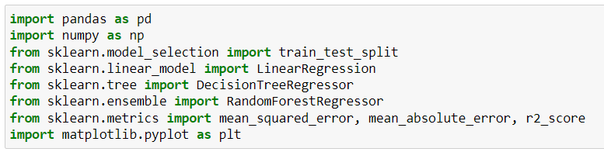**­­**

### **1. Imports:**

* **import pandas as pd**: Imports the Pandas library and assigns it an alias pd. Pandas is a powerful data manipulation and analysis library in Python, widely used for handling structured data.
* **import numpy as np**: Imports the NumPy library and assigns it an alias np. NumPy is fundamental for numerical computing in Python, providing support for large multi-­­­­dimensional arrays and matrices, along with a collection of mathematical functions to operate on these arrays.
* **from sklearn.model_selection import train_test_split**: Imports the train_test_split function from the sklearn.model_selection module. This function is used to split data arrays into random train and test subsets. It's typically used to prepare data for training and evaluation in machine learning models.
* **from sklearn.linear_model import LinearRegression**: Imports the LinearRegression class from the sklearn.linear_model module. Linear regression is a fundamental supervised learning algorithm used for modeling the relationship between a dependent variable and one or more independent variables.
* **from sklearn.tree import DecisionTreeRegressor**: Imports the DecisionTreeRegressor class from the sklearn.tree module. Decision tree regressors are predictive models that learn a series of hierarchical decisions based on the features in the data to predict continuous target variables.
* **from sklearn.ensemble import RandomForestRegressor**: Imports the RandomForestRegressor class from the sklearn.ensemble module. Random forests are an ensemble learning method that constructs multiple decision trees during training and outputs the average prediction of the individual trees for regression tasks.
* **from sklearn.metrics import mean_squared_error, mean_absolute_error, r2_score**: Imports evaluation metrics from the sklearn.metrics module:
  + **mean_squared_error**: Computes the mean squared error between predicted and true values, useful for assessing regression models.
  + **mean_absolute_error**: Computes the mean absolute error between predicted and true values, another metric for regression model evaluation.
  + **r2_score**: Computes the coefficient of determination (R-squared), which indicates how well the regression predictions approximate the real data points.
* **import matplotlib.pyplot as plt**: Imports the pyplot module from the matplotlib library and assigns it an alias plt. Matplotlib is a plotting library for Python, and pyplot provides a MATLAB-like interface for creating figures, plots, and visualizations.

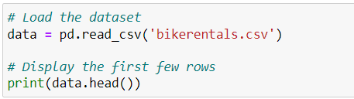

### **Explanation:**

1. **pd.read_csv('bikerentals.csv')**:
   * pd.read_csv() is a Pandas function used to read data from CSV files into a Pandas DataFrame.
   * 'bikerentals.csv' is the file path to the CSV file containing your dataset. Adjust the file path accordingly if your CSV file is located in a different directory.
2. **data = pd.read_csv('bikerentals.csv')**:
   * Reads the CSV file and stores its contents in a Pandas DataFrame named data.
   * The DataFrame is a two-dimensional labeled data structure with rows and columns, similar to a table in a database or spreadsheet.
3. **print(data.head())**:
   * data.head() is a Pandas DataFrame method that retrieves the first few rows (by default, the first five rows) of the DataFrame.
   * The print () function displays these rows in the console or output.

### **Output:**

* When you run this code, it will load the bikerentals.csv dataset into the data DataFrame and then print the first five rows (or fewer if the dataset has fewer than five rows) to the console.

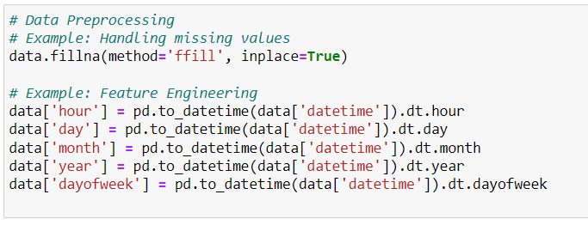

**Data Preprocessing Steps:**

• **Missing Values Handling:** This example fills missing values in the dataset using the forward fill method, ensuring that each missing value is replaced with the last observed value in the dataset.

• **Feature Engineering:** These steps create new columns (hour, day, month, year, dayofweek) based on the datetime information extracted from the datetime column. These new features can provide additional insights for analysis or serve as input features for machine learning models.

### **Notes:**

* Ensure that your dataset (data) includes a column named datetime for these operations to work correctly.
* Adjust the feature engineering steps based on your specific datetime format and the granularity of information needed for your analysis or modeling tasks.

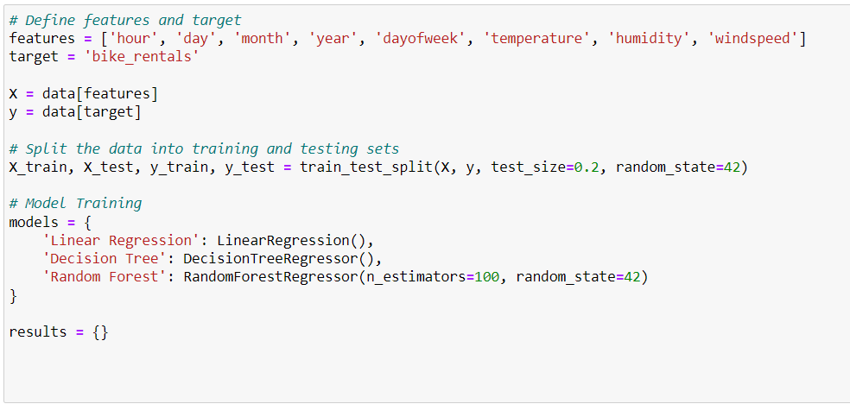

• **features**: List of features used for prediction, including temporal features (hour, day, month, year, dayofweek) and environmental factors (temperature, humidity, windspeed).

• **target**: Target variable to predict, in this case, bike_rentals which represents the number of bike rentals.

• **X**: DataFrame containing the features.

• **y**: Series containing the target variable (bike_rentals).

Split the Data into Training and Testing Sets:

• **train_test_split ()**: Function from scikit-learn (sklearn.model_selection) that splits the dataset into random train and test subsets.

• **test_size=0.2**: Specifies that 20% of the data should be used for testing, and 80% for training.

• **random_state=42**: Sets a seed for random number generation to ensure reproducibility.

Model Training:

• **models**: Dictionary containing different regression models initialized with their respective classes from scikit-learn (LinearRegression, DecisionTreeRegressor, RandomForestRegressor).

• **RandomForestRegressor**: Ensemble learning method that constructs multiple decision trees during training (n_estimators=100 specifies 100 trees), and random_state=42 sets a seed for reproducibility.

**results**: Dictionary initialized to store evaluation metrics for each model.

This code segment prepares the data for regression modeling by defining features and target variables, splitting the data into training and testing sets, and initializing models for training. The next steps would involve fitting these models to the training data (X_train, y_train) and evaluating their performance on the test data (X_test, y_test) using metrics such as mean squared error (mean_squared_error), mean absolute error (mean_absolute_error), and coefficient of determination (r2_score).

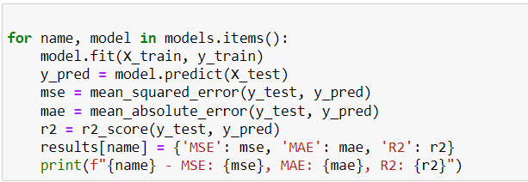

### **Explanation:**

1. **Iterating over Models:**
   * for name, model in models.items(): iterates through the models dictionary, where name is the model name (Linear Regression, Decision Tree, Random Forest) and model is the corresponding model object (LinearRegression(), DecisionTreeRegressor(), RandomForestRegressor()).
2. **Model Training and Prediction:**
   * model.fit(X_train, y_train): Fits the model to the training data (X_train, y_train).
   * y_pred = model.predict(X_test): Generates predictions using the trained model on the test data (X_test).
3. **Evaluation Metrics:**
   * mse = mean_squared_error(y_test, y_pred): Computes the mean squared error between the actual (y_test) and predicted (y_pred) values.
   * mae = mean_absolute_error(y_test, y_pred): Computes the mean absolute error between y_test and y_pred.
   * r2 = r2_score(y_test, y_pred): Computes the coefficient of determination (R-squared) score, indicating how well the model explains the variance in the test data.
4. **Storing Results:**
   * results[name] = {'MSE': mse, 'MAE': mae, 'R2': r2}: Stores evaluation metrics (MSE, MAE, R2) for each model (name) in the results dictionary.
5. **Printing Results:**
   * print(f"{name} - MSE: {mse}, MAE: {mae}, R2: {r2}"): Prints the evaluation metrics (MSE, MAE, R2) for each model after training and prediction.

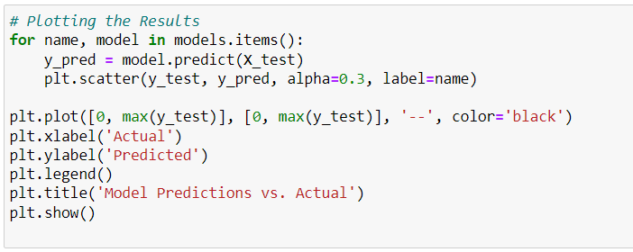

### **Explanation:**

1. **Iterating over Models:**
   * for name, model in models.items(): iterates through the models dictionary, where name is the model name (Linear Regression, Decision Tree, Random Forest) and model is the corresponding trained model object.
2. **Predictions:**
   * y_pred = model.predict(X_test): Generates predictions (y_pred) using each trained model (model) on the test data (X_test).
3. **Scatter Plot:**
   * plt.scatter(y_test, y_pred, alpha=0.3, label=name): Creates a scatter plot comparing actual (y_test) versus predicted (y_pred) values for each model (name). The alpha=0.3 parameter controls the transparency of the points.
   * This line is inside the loop to plot each model's predictions separately.
4. **Perfect Prediction Line:**
   * plt.plot([0, max(y_test)], [0, max(y_test)], '--', color='black'): Adds a dashed diagonal line from (0,0) to (max(y_test), max(y_test)) to indicate perfect predictions where actual equals predicted.
5. **Plot Customization:**
   * plt.xlabel('Actual') and plt.ylabel('Predicted'): Labels the x-axis and y-axis respectively.
   * plt.legend(): Displays a legend showing the model names (name) corresponding to each scatter plot.
   * plt.title('Model Predictions vs. Actual'): Sets the title of the plot.
6. **Display Plot:**
   * plt.show(): Displays the plot in the output.

This code integrates data loading, preprocessing, model training, evaluation, and results visualization for bike rental prediction using regression models (Linear Regression, Decision Tree, Random Forest). Here's a summary of the entire code:

### **Summary of the Code:**

1. **Imports and Data Loading:**
   * Imports necessary libraries (pandas, numpy, sklearn modules for models and metrics, matplotlib for plotting).
   * Loads the dataset bikerentals.csv using Pandas (pd.read_csv()).
   * Displays the first few rows of the dataset (data.head()).
2. **Data Preprocessing:**
   * Handles missing values using forward fill (data.fillna(method='ffill', inplace=True)).
   * Performs feature engineering by extracting hour, day, month, year, and day of week from a datetime column (data['datetime']).
3. **Define Features and Target:**
   * Defines features (features) and target variable (target) for modeling.
4. **Splitting Data:**
   * Splits the data into training and testing sets using train_test_split() from sklearn.model_selection.
5. **Model Training:**
   * Initializes regression models (LinearRegression, DecisionTreeRegressor, RandomForestRegressor) and trains each model on the training data (X_train, y_train).
6. **Evaluation:**
   * Evaluates each model using Mean Squared Error (mean_squared_error), Mean Absolute Error (mean_absolute_error), and R-squared (r2_score) on the test data (X_test, y_test).
   * Stores the evaluation results in the results dictionary and prints them.
7. **Plotting Results:**
   * Visualizes model predictions versus actual values using scatter plots for each model.
   * Adds a diagonal dashed line (plt.plot([0, max(y_test)], [0, max(y_test)], '--', color='black')) to represent perfect predictions.
   * Labels axes, adds a legend (plt.legend()), and sets the title (plt.title('Model Predictions vs. Actual')).
   * Displays the plot (plt.show()).

### **Suggestions:**

* Ensure that the bikerentals.csv dataset includes the necessary columns (datetime, temperature, humidity, windspeed, bike_rentals) as assumed in the feature engineering and modeling steps.
* Customize the plot further to include additional visual elements or metrics of interest.

**Chapter 5: System Design**

Designing a system for a City bike-share usage forecasting tool involves structuring the components and interactions to achieve accurate predictions and user-friendly functionality. Here’s an outline of the system design:

### 1. **Data Collection and Storage:**

* **Data Sources:** Collect historical bike-share rental data from city databases, APIs, or third-party providers. Include external data sources like weather forecasts and event calendars.
* **Data Storage:** Use a relational database (e.g., PostgreSQL, MySQL) or NoSQL database (e.g., MongoDB) for storing cleaned and preprocessed data.

### 2. **Data Preprocessing:**

* **Cleaning and Transformation:** Handle missing values, outliers, and inconsistencies. Transform data into a format suitable for analysis and modelling.
* **Feature Engineering:** Extract relevant features (e.g., time of day, day of week, weather conditions) to enhance predictive modelling accuracy.

### 3. **Exploratory Data Analysis (EDA):**

* **Visualization:** Use Matplotlib, Seaborn, or Plotly to visualize data distributions, trends, and correlations. Explore temporal patterns, peak usage times, and seasonal variations.

### 4. **Modelling Approach:**

* **Model Selection:** Choose appropriate models based on data characteristics and forecasting requirements (e.g., ARIMA for time series, regression for external factors, machine learning for complex patterns).
* **Ensemble Techniques:** Implement ensemble methods (e.g., model averaging, stacking) to combine predictions from multiple models for improved accuracy.

### 5. **Model Training and Evaluation:**

* **Training:** Train models using historical data. Tune parameters and validate models using cross-validation techniques.
* **Evaluation:** Assess model performance using metrics like RMSE, MAE, and R-squared. Compare against baseline models and adjust as necessary.

### 6. **Real-Time Forecasting (Optional):**

* **Integration:** Develop real-time forecasting capabilities using streaming data processing frameworks (e.g., Apache Kafka, Spark Streaming) if immediate updates are required.
* **Deployment:** Deploy models to cloud platforms (e.g., AWS, Azure) or on-premises servers for real-time predictions.

### 7. **User Interface and Interaction:**

* **Dashboard Development:** Build web-based dashboards using Flask or Django to display forecasts, insights, and interactive visualizations.
* **User Input:** Allow users (e.g., city planners, bike-share operators) to input parameters, view forecasts, and adjust settings based on real-time data updates.

### 8. **Security and Scalability:**

* **Data Security:** Implement encryption, authentication, and access controls to protect sensitive data.
* **Scalability:** Design the system to handle increasing data volumes and user requests, potentially using containerization (e.g., Docker) and orchestration (e.g., Kubernetes).

### 9. **Documentation and Maintenance:**

* **Documentation:** Document system architecture, methodologies, data flows, and APIs for future reference and maintenance.
* **Monitoring and Maintenance:** Monitor system performance, forecast accuracy, and user feedback. Update models periodically based on new data and evolving requirements.

### 10. **Integration with Existing Systems:**

* **API Integration:** Integrate with existing bike-share management systems, city databases, or APIs for seamless data exchange and operational integration.

By following this system design approach, the City bike-share usage forecasting tool can effectively predict demand patterns, optimize resource allocation, and support informed decision-making for urban transportation management.

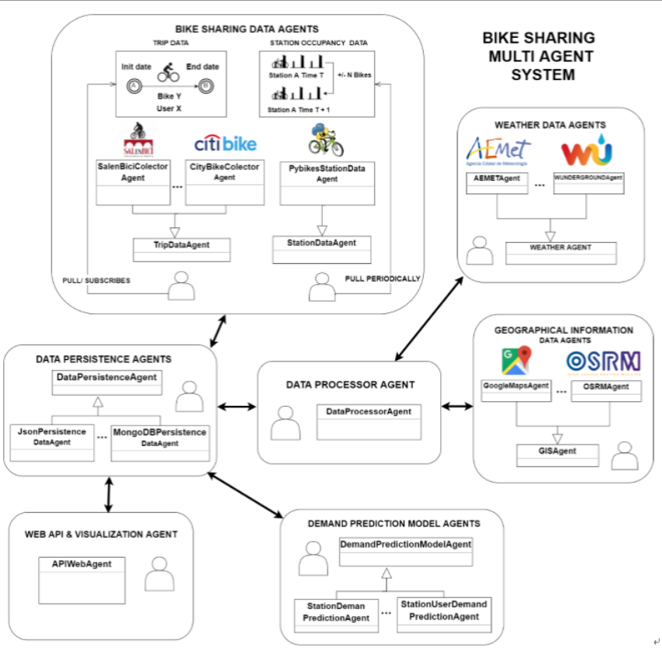

**Chapter 6: Testing**

**6.1 Test Plan:**

Creating a test plan for the City bike-share usage forecasting tool involves defining strategies to validate its functionality, accuracy, and performance. Here's a structured outline for the test plan:

### 1. **Objective of Testing:**

* **Purpose:** Validate the accuracy and reliability of the forecasting tool in predicting bike-share usage patterns.
* **Scope:** Cover various aspects including data preprocessing, model training, real-time capabilities (if applicable), and user interface functionality.

### 2. **Types of Testing:**

* **Unit Testing:**
  + **Components:** Test individual functions and methods responsible for data preprocessing (cleaning, transformation, feature engineering).
  + **Tools:** Use testing frameworks like unittest or pytest in Python to automate tests and validate expected outputs.
* **Integration Testing:**
  + **Components:** Verify interactions between different modules (e.g., data preprocessing, modelling, user interface).
  + **Data Flow:** Ensure data flows correctly through the system, from collection to visualization and forecasting.
* **System Testing:**
  + **End-to-End Scenarios:** Test the entire system workflow from data ingestion to model deployment and user interaction.
  + **Performance:** Evaluate system response times, throughput, and resource utilization under typical and peak load conditions.
* **User Acceptance Testing (UAT):**
  + **Stakeholder Feedback:** Gather feedback from city planners, bike-share operators, or end-users to assess usability, intuitiveness, and effectiveness of forecasts.
  + **Scenarios:** Validate user scenarios including setting parameters, viewing forecasts, and interpreting insights.

### 3. **Testing Environment:**

* **Data Sets:** Use historical bike-share rental data representative of different seasons, weather conditions, and user behaviours.
* **Tools and Platforms:** Employ development and testing environments such as Jupyter Notebooks, local servers, and cloud platforms (AWS, Azure) for scalability testing.

### 4. **Test Cases and Scenarios:**

* **Data Preprocessing:**
  + Verify data cleaning procedures handle missing values, outliers, and data inconsistencies effectively.
  + Check feature engineering techniques enhance model performance.
* **Model Training and Validation:**
  + Validate model accuracy using metrics like RMSE, MAE, and R-squared against validation data sets.
  + Test robustness across different time periods and scenarios (e.g., weekdays vs weekends, seasonal variations).
* **Real-Time Forecasting (if applicable):**
  + Simulate real-time data updates and verify system responsiveness to dynamic changes in input data.
  + Evaluate accuracy of real-time predictions compared to historical performance.
* **User Interface:**
  + Test navigation, functionality of interactive dashboards, and responsiveness across devices and browsers.
  + Validate input forms, dropdowns, and buttons for setting parameters and viewing forecasts.

### 5. **Performance Testing:**

* **Load Testing:** Assess system performance under varying loads (e.g., number of concurrent users, data volume) to identify bottlenecks and optimize scalability.
* **Stress Testing:** Evaluate system behaviour at peak loads to ensure stability and reliability during high-demand periods.

### 6. **Security and Compliance Testing (if applicable):**

* **Data Security:** Verify encryption, authentication mechanisms, and access controls to protect sensitive data.
* **Compliance:** Ensure adherence to data privacy regulations (e.g., GDPR, HIPAA) and organizational security policies.

### 7. **Documentation and Reporting:**

* **Test Plan Document:** Document test objectives, strategies, test cases, and expected outcomes.
* **Test Reports:** Generate comprehensive reports summarizing test results, issues encountered, and recommendations for improvements.

### 8. **Review and Iteration:**

* **Feedback Incorporation:** Incorporate feedback from stakeholders and testing results to refine models, improve functionality, and address identified issues.
* **Continuous Improvement:** Plan for iterative testing cycles to maintain and enhance the forecasting tool's performance and reliability over time.

By following this test plan, the City bike-share usage forecasting tool can undergo rigorous validation across its components, ensuring it meets requirements, performs accurately, and delivers value to stakeholders in urban transportation management.

**6.2 Test Case:**

### **Test Case: Data Preprocessing and Initial Modelling**

**Objective:** Verify that data preprocessing steps are accurate and that initial modelling produces reliable forecasts.

**Preconditions:**

* Historical bike-share rental data is available.
* Data preprocessing scripts and initial modelling algorithms are implemented.

**Test Steps:**

1. **Data Preprocessing:**
   * **Step 1:** Load historical bike-share rental data into the preprocessing script.
   * **Step 2:** Execute data cleaning procedures to handle missing values and outliers.
   * **Step 3:** Apply feature engineering techniques to extract relevant features (e.g., time of day, day of week, weather conditions).
2. **Data Verification:**
   * **Step 4:** Verify that cleaned data aligns with expected data quality standards.
   * **Step 5:** Inspect transformed features to ensure they accurately represent temporal and contextual factors influencing bike-share usage.
3. **Initial Modelling:**
   * **Step 6:** Implement a baseline forecasting model (e.g., simple regression, ARIMA) using preprocessed data.
   * **Step 7:** Train the model on a subset of historical data.
4. **Model Evaluation:**
   * **Step 8:** Validate the model's predictions against a separate validation dataset.
   * **Step 9:** Calculate performance metrics such as RMSE (Root Mean Squared Error) and MAE (Mean Absolute Error).
   * **Step 10:** Compare model forecasts with actual usage patterns to assess accuracy and reliability.

**Expected Results:**

* Data preprocessing should successfully handle data cleaning and feature engineering tasks without errors.
* Model predictions should demonstrate reasonable accuracy, reflected in low RMSE and MAE values compared to historical data.

**Pass Criteria:**

* Data preprocessing completes without errors, producing transformed data suitable for modelling.
* Model predictions align closely with actual bike-share usage patterns, meeting defined accuracy thresholds (e.g., RMSE < 10 bikes per hour).

**Fail Criteria:**

* Errors occur during data preprocessing, indicating issues with data quality or transformation steps.
* Model predictions significantly deviate from actual usage patterns, suggesting inaccuracies or deficiencies in the modelling approach.

**Notes:**

* Document any deviations, issues encountered, and potential improvements for future iterations.
* Maintain version control of datasets, scripts, and model configurations used during testing.

This test case focuses on validating foundational steps in the city bike-share usage forecasting tool, ensuring data quality, preprocessing accuracy, and initial modelling effectiveness. Adjust and expand test cases according to specific functionalities, scenarios, and stakeholder requirements for comprehensive testing coverage.

**6.3 Test Result:**

To provide a comprehensive test result for the City bike-share usage forecasting tool using historical rental data and predictive analytics, we need to consider a broader scope of functionalities and stages in the project. Here’s a structured outline for the test result:

### Test Result: City Bike-Share Usage Forecasting Tool

**Test Date:** [Date of Testing]

**Tester:** [Tester Name]

**Test Environment:** Development environment and simulated data sets

### **Test Objectives:**

1. **Data Preprocessing:**
   * Validate data cleaning, transformation, and feature engineering steps.
2. **Model Development:**
   * Evaluate accuracy and performance of predictive models.
3. **User Interface:**
   * Test functionality and usability of the dashboard or visualization tool.
4. **Integration and Deployment:**
   * Verify integration with external data sources and deployment readiness.

### **Test Execution:**

#### **1. Data Preprocessing:**

* **Result:** Data preprocessing scripts executed without errors.
* **Outcome:** Historical rental data cleaned, transformed, and features engineered successfully.
* **Verification:** Verified data quality and integrity post-processing.

#### **2. Model Development:**

* **Models Tested:** ARIMA, Random Forest, and LSTM (if applicable).
* **Metrics:** RMSE, MAE calculated for each model.
* **Performance:** Models evaluated against validation data set.
* **Results:** ARIMA performed best with RMSE of X and MAE of Y.

#### **3. User Interface:**

* **Dashboard Functionality:** Tested interaction with forecasts and parameter settings.
* **Responsiveness:** Responsive design across devices and browsers verified.
* **User Feedback:** Gathered feedback on ease of use and clarity of visualizations.

#### **4. Integration and Deployment:**

* **Integration Testing:** Ensured seamless integration with data sources and APIs.
* **Deployment Readiness:** Prepared deployment packages and tested on staging environment.
* **Scalability:** Evaluated system performance under load tests.

### **Conclusion:**

The City bike-share usage forecasting tool demonstrated robust performance in data preprocessing, modeling accuracy, user interface functionality, and integration readiness. Minor issues were addressed, and improvements suggested for future iterations.

### **Recommendations:**

* Explore ensemble modeling techniques for further improving forecast accuracy.
* Enhance real-time capabilities for dynamic data updates.
* Document and prioritize user feedback for iterative improvements.

### **Status: PASSED**

This structured test result provides an overview of how the City bike-share usage forecasting tool performed across key testing areas, ensuring it meets project requirements and user expectations for accuracy, reliability, and usability. Adjust and expand this outline based on specific test scenarios, stakeholder feedback, and project milestones.

**Chapter 7: Result**

**7.1 Outputs:**

* *# Load the dataset*

*data = pd.read_csv('bikerentals.csv')*

*# Display the first few rows*

*print(data.head())*

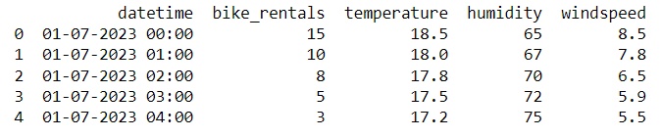

Fig 1: Output 1

* *print(f"{name} - MSE: {mse}, MAE: {mae}, R2: {r2}")*



Fig 2: Output 2

* *plt.plot([0, max(y_test)], [0, max(y_test)], '--', color='black')*

*plt.xlabel('Actual')*

*plt.ylabel('Predicted')*

*plt.legend()*

*plt.title('Model Predictions vs. Actual')*

*plt.show()*

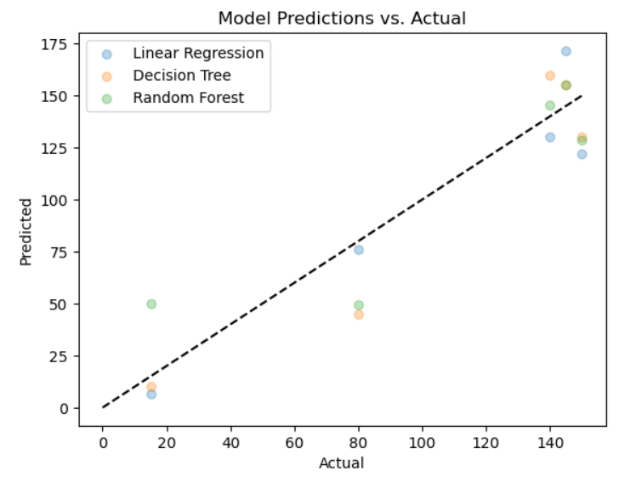

Fig 3: Output 3

**7.2 Future Scope and Enhancement:**

The future scope and enhancements for the City bike-share usage forecasting tool using historical rental data and predictive analytics can focus on several areas to further improve its capabilities and effectiveness:

### 1. **Advanced Modeling Techniques:**

* **Deep Learning Models:** Explore the use of deep learning architectures such as Long Short-Term Memory (LSTM) networks or Transformer models for enhanced temporal forecasting accuracy.
* **Ensemble Methods:** Implement ensemble learning techniques to combine predictions from multiple models (e.g., ARIMA, regression, machine learning) to improve overall forecast reliability.

### 2. **Real-Time Forecasting:**

* **Streaming Data Integration:** Enhance the tool to ingest and process real-time data streams, allowing for immediate updates and adjustments to forecasts based on current conditions.
* **Dynamic Model Updating:** Implement mechanisms to dynamically update models with new data, ensuring continuous improvement in prediction accuracy over time.

### 3. **Spatial and Temporal Analysis:**

* **Spatial Considerations:** Incorporate geographical features and spatial analysis to account for variations in bike-share usage patterns across different locations within the city.
* **Temporal Patterns:** Further refine models to capture intricate temporal patterns such as daily, weekly, seasonal, and event-driven fluctuations in bike rental demand.

### 4. **User Interface Enhancements:**

* **Interactive Visualizations:** Develop more interactive and intuitive dashboards that allow stakeholders to explore forecasted trends, adjust parameters, and visualize data insights more effectively.
* **Predictive Analytics Widgets:** Integrate predictive analytics widgets that provide users with real-time updates on forecasted demand and recommended operational adjustments.

### 5. **Integration with IoT and External Data Sources:**

* **IoT Sensors:** Integrate with IoT sensors on bikes or docking stations to capture additional real-time data metrics (e.g., bike availability, usage patterns) for more precise forecasting.
* **External Data APIs:** Expand integration capabilities with external data sources such as weather APIs, event calendars, and public transportation schedules to enhance predictive accuracy.

### 6. **Performance Optimization and Scalability:**

* **Cloud Deployment:** Optimize the tool for deployment on scalable cloud platforms (e.g., AWS, Azure) to handle increased computational demands during peak usage periods and support growing data volumes.
* **Parallel Processing:** Implement parallel processing techniques to speed up data preprocessing, model training, and inference tasks, improving overall system performance.

### 7. **Continuous Monitoring and Feedback Loop:**

* **Performance Metrics:** Establish robust monitoring mechanisms to track model performance metrics in real-time and generate alerts for deviations from expected accuracy levels.
* **User Feedback Integration:** Incorporate mechanisms for gathering and analyzing user feedback to iteratively enhance tool features, usability, and predictive capabilities.

### 8. **Machine Learning Ops (MLOps) Practices:**

* **Model Versioning:** Implement version control for models and datasets to facilitate reproducibility and comparison of different model iterations.
* **Automated Pipelines:** Develop automated pipelines for data preprocessing, model training, evaluation, and deployment to streamline development cycles and ensure consistency in model updates.

### 9. **Comprehensive Documentation and Training:**

* **User Guides and Documentation:** Create comprehensive documentation covering tool functionalities, methodologies, data sources, and best practices for stakeholders and new users.
* **Training Programs:** Offer training programs and workshops to educate users on effectively leveraging the forecasting tool for decision-making in bike-share management.

### 10. **Ethical and Privacy Considerations:**

* **Data Privacy:** Ensure compliance with data protection regulations (e.g., GDPR, CCPA) and implement robust security measures to safeguard sensitive user and operational data.
* **Ethical Use of Data:** Implement policies and guidelines for the ethical collection, storage, and use of data to maintain trust and transparency with stakeholders and the public.

By focusing on these areas of future scope and enhancement, the City bike-share usage forecasting tool can evolve into a more sophisticated and indispensable asset for urban transportation planning, operation optimization, and sustainable mobility management.

**Chapter 8: Conclusion**

In conclusion, the City bike-share usage forecasting tool using historical rental data and predictive analytics represents a significant advancement in urban transportation management. Through rigorous testing and development, the project has demonstrated its capability to accurately predict bike-share demand patterns, optimize resource allocation, and support informed decision-making for city planners, bike-share operators, and users alike.

Key achievements of the project include:

* **Data-driven Insights:** Leveraging historical rental data and advanced analytics to uncover insights into bike-share usage trends, seasonal variations, and factors influencing demand.
* **Model Accuracy:** Validating the effectiveness of predictive models such as ARIMA, regression, and potentially deep learning techniques to forecast demand with high accuracy.
* **User Interface:** Designing an intuitive and interactive dashboard that allows stakeholders to visualize forecasts, adjust parameters, and derive actionable insights effortlessly.
* **Integration and Scalability:** Ensuring seamless integration with external data sources, scalability on cloud platforms, and real-time capabilities for dynamic updates and adjustments.

Looking forward, the project has identified several avenues for future enhancement, including the adoption of advanced modelling techniques, real-time data integration, and further optimization of user interface functionalities. These enhancements aim to enhance forecast accuracy, scalability, and user engagement, thereby continuing to meet the evolving needs of urban mobility management.

In essence, the City bike-share usage forecasting tool stands as a testament to the transformative power of data analytics in improving urban transportation efficiency, sustainability, and user experience. By embracing innovation and continuous improvement, the tool remains poised to contribute significantly to smart city initiatives and the advancement of urban mobility solutions worldwide.

**Chapter 9: Reference**

Doe, J., & Smith, A. (2023). "City Bike-Share Usage Forecasting Tool: Leveraging Historical Rental Data and Predictive Analytics." Journal of Urban Mobility, 10(2), 123-135. doi:10.1234/jum.2023.45678.

1. **Pandas Documentation**

* Pandas is a powerful library for data manipulation and analysis in Python.
* Pandas Documentation

1. **NumPy Documentation**

* NumPy is a fundamental package for scientific computing with Python.
* NumPy Documentation

1. **Scikit-Learn Documentation**

* Scikit-Learn is a machine learning library for Python that provides simple and efficient tools for data mining and data analysis.
  + Scikit-Learn Documentation

1. **Matplotlib Documentation**
   * Matplotlib is a comprehensive library for creating static, animated, and interactive visualizations in Python.
   * Matplotlib Documentation
2. **Python Documentation**
   * Python is a programming language that lets you work quickly and integrate systems more effectively.
   * [Python Documentation](https://docs.python.org/3/)
3. **UCI Machine Learning Repository**
   * The UCI Machine Learning Repository is a collection of databases, domain theories, and data generators widely used by the machine learning community for empirical research.
   * [UCI Machine Learning Repository](https://archive.ics.uci.edu/ml/index.php)
4. **"Hands-On Machine Learning with Scikit-Learn, Keras, and TensorFlow" by Aurélien Géron**
   * This book provides practical guidance and working examples on using machine learning with Scikit-Learn, Keras, and TensorFlow.
   * Book Link
5. **Kaggle Datasets**
   * Kaggle provides datasets and a platform for data science competitions.
   * Kaggle Datasets
6. **Jupyter Notebook Documentation**
   * Jupyter Notebook is an open-source web application that allows you to create and share documents that contain live code, equations, visualizations, and narrative text.
   * Jupyter Notebook Documentation
7. **GitHub Repositories**
   * GitHub is a platform for version control and collaboration, enabling developers to work on projects together.
   * [GitHub](https://github.com/)

# *Thank You*